Chemistry 141 Name

Dr. Cary Willard

Exam 2B October 20, 2009

Multiple Choice (30 points)

Page 1 (18 points)

Page 2 (20 points)

Page 3 (13 points)

Page 4 (12 points)

Page 5 (16 points)

Total (109 points)

Chemistry Formulas

Kinetic energy = ½ mv2

w = -PΔV

Ptotal = P1+P2+P3+…

u = (3RT/MW)½

ΔG = ΔH - TΔS

PV = nRT

Rate ∝ (MW)-½

P1=X1\*Ptotal

C = q/ΔT

Ptotal = P1 + P2 + P3 + …

M = mol/L

K = oC + 273.16

w=dxF

E = mc2

HΨ=EΨ

M1V1 = M2V2

Ptotal = P1 + P2 + P3 + …

M = mol/L

Constants

h = 6.626 x 10-34 J sec

c= 2.9979 x 108 m/sec

e = 1.602 x 10-19 C

NA = 6.022 x 1023/mol

k = 1.381 x 10-23 J/K

K = oC + 273.16

1 kcal = 4.184 kJ

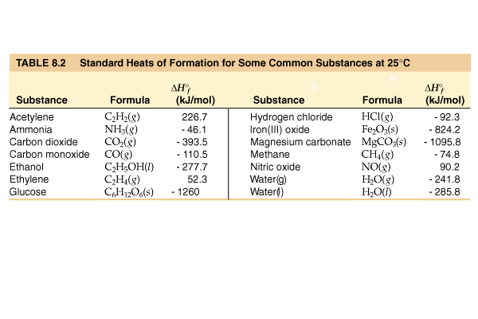R = 0.0821 L atm/mol K = 62.4 L torr/mol K = 8.31 kJ/mol K

Standard Temperature and Pressure = 0oC and 1 atm

760 torr = 760 mm Hg = 1.00 atm = 101 kPa = 14.6 psi = 30 in Hg

Specific heat water = 4.184 J/g K

Specific heat Al = 0.902 J/ g K

Specific heat Cu = 0.385 J/g K

ΔHvaporization (H2O) = 2260 J/g

ΔHfusion (H2O) = 333 J/g

mass electron = 9.109 x 10-31 kg

|  |  |  |  |  |
| --- | --- | --- | --- | --- |
| Average Bond dissociation Energies (kJ/mol) | | | | |
| H—H 436\* | C—H 410 | N—H 390 | O—H 460 | F—F 159\* |
| H—C 410 | C—C 350 | N—C 300 | O—C 350 | Cl—Cl 243\* |
| H—F 570\* | C—F 450 | N—F 270 | O—F 180 | Br—Br 193\* |
| H—Cl 432\* | C—Cl 330 | N—Cl 200 | O—Cl 200 | I—I 151\* |
| H—Br 366\* | C—Br 270 | N—Br 240 | O—Br 210 | S—F 310 |
| H—I 298\* | C—I 240 | N—I | O—I 220 | S—Cl 250 |
| H—N 390 | C—N 300 | N—N 240 | O—N 200 | S—Br 210 |
| H—O 460 | C—O 350 | N—O 200 | O—O 180 | S—S 225 |
| H—S 340 | C—S 260 | N—S | O—S 364 |  |
|  |  |  |  |  |
| C=C 611 | C=O 732 | O=O 498\* | O=S 535 | N=O 598 |
| C≡C 837 | C≡N 891 | N≡N 946\* |  |  |
| \*Bond dissociation energies for diatomic molecules are exact. | | | | |

TB07_001Part I -- Multiple choice questions (30 points)

1. Suppose you needed to closely monitor small changes in pressure inside a container using an open end manometer. For the best accuracy, the substance in the manometer should
   1. Have a low density
   2. Have a high density
   3. Be mercury
   4. Be a gas
2. According to the kinetic molecular theory, the pressure of a gas in a container will increase if the
   1. number of collisions with the container wall decreases.
   2. number of moles of the gas decreases.
   3. temperature of the gas increases.
   4. volume of the container increases.
3. Which statement about real gases is **true**?
   1. The mass of the gas particles is zero.
   2. The behavior of real gases can be exactly predicted using the ideal gas law.
   3. The volume of the gas particles is zero.
   4. Forces of attraction and repulsion exist between gas particles at close range.
4. You are given two flasks of equal volume. One contains H2 at 0oC and 1 atm while the other contains CO2 at 0oC and 2 atm. Which of the following quantities will be the same for both flasks?
   1. average molecular speed
   2. average molecular kinetic energy
   3. number of molecules present
   4. density
5. Which one of the following gases will have the **lowest** rate of effusion?

|  |  |  |  |
| --- | --- | --- | --- |
| * 1. SF4 | * 1. SCl4 | * 1. S2O5 | * 1. SO3 |

1. 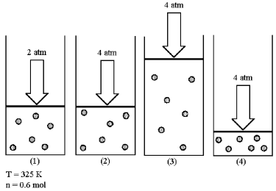Assume that you have a sample of gas in a cylinder with a moveable piston, as shown in diagram (1). The initial pressure, number of moles, and temperature of the gas are noted on the diagram.

Which diagram (2)-(4) most closely represents the result of doubling the pressure while keeping the temperature and number of moles of gas constant?

* 1. Diagram 2
  2. Diagram 3
  3. Diagram 4

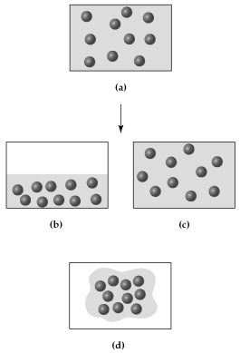

1. Assume that you have a sample of gas at 300 K in a sealed container, as represented in (a).

Which of the drawings (b)-(d) represents the gas after the temperature is lowered from 300 K to 200 K?

* 1. Drawing b
  2. Drawing c
  3. Drawing d

1. Three identical flasks contain three different gases at standard temperature and pressure. Flask A contains C4H10, flask B contains SO2, and flask C contains He. Which flask contains the largest number of molecules?
   1. flask A
   2. flask B
   3. flask C
   4. All contain same number of molecules.
2. The nutritional calorie (abbreviated Cal) is equal to
   1. 1 kcal
   2. 1000 kcal
   3. 4.184 J
   4. 4.184 cal
3. For most chemical reactions
   1. Δ*E* is much larger than Δ*H*.
   2. the difference between Δ*H* and Δ*E* is very small.
   3. Δ*H* is much larger than Δ*E*.
   4. Δ*H* is equal to Δ*E*.
4. For a particular process that is carried out at constant pressure, *125 kJ of heat is released* and 15 kJ of work is done. Therefore,
   1. Δ*E* = −110 kJ and Δ*H* = −125 kJ.
   2. Δ*E* = −125 kJ and Δ*H* = 140 kJ.
   3. Δ*E* = −140 kJ and Δ*H* = −125 kJ.
   4. Δ*E* = −125 kJ and Δ*H* = −110 kJ.
5. Water has an unusually high

|  |  |
| --- | --- |
| * 1. Calorimeter constant | * 1. specific heat |
| * 1. heat of combustion | * 1. heat of formation |

1. For which should the standard heat of formation Δ*Hof*, be zero at 25oC?
   1. O (g)
   2. O2 (g)
   3. O3 (g)
   4. All of the above
2. The values of Δ*Hºf* for the three states of benzene are approximately -22 kcal/mol, -11 kcal/mol, and 20 kcal/mol. Which is the value for solid benzene?
   1. -11 kcal/mol
   2. -22 kcal/mol
   3. 20 kcal/mol
   4. cannot be determined without additional information
3. Which equation represents the reaction whose Δ*H*, represents the standard enthalpy of formation of CHCl3(*l*) at 25oC? (*i.e.*, for which is Δ*H* = Δ*Hof* of CHCl3)
   1. C(*s*) + 1/2 H2(*g*) + 3/2 Cl2(*g*) 🡪 CHCl3(*l*)
   2. 2 C(*s*) + H2(*g*) + 3 Cl2(*g*) 🡪 2 CHCl3(*l*)
   3. CHCl3(*l*) 🡪 C(*s*) + H(*g*) + 3 Cl(*g*)
   4. C(*s*) + H(*g*) + 3 Cl(*g*) 🡪 CHCl3(*l*)

Part II -- Problems (79 points)

1. (4 points) Carry out the following conversions
   1. 642 torr to kPa
 $$?kPa=642 torr×\frac{101 kPa}{760 torr}= 85.3 kPa$$

  2. 0.401 atm to mm Hg
$$?mm Hg=0.401 atm×\frac{760 mm Hg}{1 atm}= 305 mm Hg$$

2. (9 points) A compressed air tank carried by scuba divers has a volume of 6.0 L and a pressure of 160 atm at 20oC.
   1. What would the pressure of the air be in a tank with a volume of 16.0 L?
 $$\frac{P_{1}V_{1}}{n_{1}T_{1}}=\frac{P_{2}V_{2}}{n_{2}T_{2}}→P_{2}=P_{1}\left(\frac{V_{1}}{V_{2}}\right)=160 atm\left(\frac{6.0 L}{16.0 L}\right)=60 atm$$

  2. What would the pressure of the air in the tank be if the temperature increased to 45oC?
   3. What is the volume of air in the tank in liters at STP (0oC and 1 atm)?
3. (5 points) Methane gas, CH4, is sold in a 43.8 L cylinder containing 6.38 kg of methane. What is the pressure inside the cylinder in atm if the temperature is 21oC?
4. (5 points) Use kinetic molecular theory to explain the change in pressure that results from warming a sample of gas.

As the gas warms, the speed of the molecules increases thus hitting the surfaces harder and increasing pressure.

1. (5 points) What is the pressure in millimeter of mercury inside a container of gas connected to a mercury-filled open-end manometer when the level in the arm connected to the container is 23.5 cm lower than the level in the arm open to the atmosphere and the atmospheric pressure reading outside the apparatus is 754.3 mm Hg?

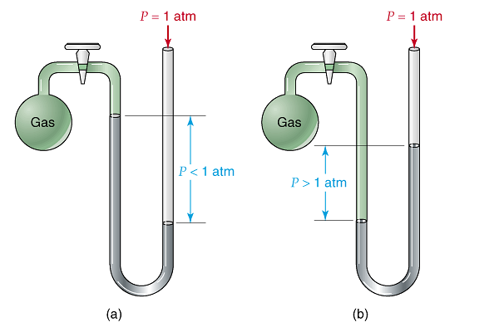

Pressure gas =pressure atmosphere + pressure Hg

Pressure gas = 235 mm Hg + 754.3 mm Hg

Pressure gas = 989 mm Hg

1. (5 points) An unknown gas is placed in a 1.500 L bulb at a pressure of 572 mm Hg and a temperature of 22.5 oC, and is found to weigh 0.9847 g. What is the molecular mass of the gas?
$$molar mass=\frac{mass gas}{mol gas}=\frac{0.9847 g}{1.500 L}×\frac{32.3L}{mol}=\frac{21.2 g}{mol}$$

$$PV=nRT→\frac{V}{n}=\frac{RT}{P}=\frac{\left(62.4 L torr\right)\left(295.7 K\right)}{\left(572 torr\right)mol K}=\frac{ 32.3 L}{mol}$$

2. (5 points) If a 0.500 mole sample of Krypton requires 16.7 minutes to effuse through a porous membrane and a 0.500 mole sample of an unknown gas requires 41.6minutes, calculate the molar mass of the unknown gas.

$\frac{{rate}_{Ar}}{{rate}_{?}}=\sqrt{\frac{{MW}_{?}}{{MW}_{Kr}}}$ $\frac{\left(\frac{0.500 mol}{16.7 min}\right)}{\left(\frac{0.500 mol}{41.6 min}\right)}=\frac{41.6 min}{16.7 min}=2.49=\sqrt{\frac{?}{83.8 g/mol}}$

$$6.21=\frac{?}{83.8 g/mol}→→ ?=\left(6.21\right)\left(83.8 g/mol\right)=\boxed{ 520. g/mol}$$

1. (4 points) Sodium metal is sometimes used as a cooling agent in heat exchange units because of its relatively high molar heat capacity of 28.2 J/mol oC. What is the specific heat of sodium in J/g K?
$$\frac{28.2 J}{mol ℃}×\frac{1 mol Na}{22.99 g Na}×\frac{1 ℃}{1 K}=\frac{1.23 J }{g K}$$

2. (9 points) The bombardier beetle uses an explosive discharge as a defense mechanism. The chemistry of the reaction involved is the oxidation of hydroquinone by H2O2 to produce quinone and water.

C6H4(OH)2(aq) + H2O2(aq) 🡪 C6H4O2(aq) + 2 H2O(l)

Given the following reactions, calculate ΔH.

C6H4(OH)2(aq) 🡪 C6H4O2(aq)  + H2(g)  ΔH = + 177.4 kJ

H2(g) + 1/2O2(g)  🡪 H2O(g)  ΔH = − 241.8 kJ

H2(g) + O2(g)  🡪 H2O2(aq)  ΔH = −191.2 kJ

H2O(g)  🡪 H2O(l )  ΔH = − 43.8 kJ

C6H4(OH)2(aq) 🡪 C6H4O2(aq)  + H2(g)  + 177.4 kJ

H2O2(aq)  🡪 H2(g) + O2(g)  +191.2 kJ

2(H2(g) + 1/2O2(g)  🡪 H2O(g)  ) 2(−241.8 kJ) = − 483.6 kJ

2(H2O(g)  🡪 H2O(l )) 2(−43.8 kJ) =−87.6 kJ

C6H4(OH)2(aq) + H2O2(aq) 🡪 C6H4O2(aq) + 2 H2O(l)  − 202.6 kJ

How much heat is produced by a bombardier beetle that produces 25.0 mg of quinone?

$$?kJ=25.0 mgC_{6}H_{4}O_{2}×\frac{1 g}{1000 mg}×\frac{1 mol }{108.04 g}×\frac{202.6 kJ}{1 mol}=0.0469 kJ or 46.9 J$$

1. (6 points) The standard enthalpy of combustion of cyclo-octane (C8H16) is −1186.0 kJ/mol. The products of this combustion are liquid water and carbon dioxide gas. Calculate the standard enthalpy of formation of liquid cyclo-octane

C8H16(g) + 12 O2(g) ⎯→ 8 CO2(g) + 8 H2O(l)

Hc, (C8H16, g) = 8(Hf, CO2, g) + 8 (Hf, H2O, l)- 1 (Hf, C8H16) – 12(Hf, O2, g)

-86  kJ = 8(-393.5 kJ) + 8 (-285.8 kJ) - 1 (Hf, C8H16) – 12(0 kJ)

-1186.0 kJ = -3148.0 kJ + -2286.4 kJ - (Hf, C8H16) -0 kJ

-1186.0 kJ = -5434.4 kJ - (Hf, C8H16)

- (Hf, C8H16) = + 4248.4 kJ

(Hf, C8H16)= -4248.4 kJ/mol

1. (6 points) Determine the energy of the following reaction using bond dissociation energies.



|  |  |  |  |  |
| --- | --- | --- | --- | --- |
| Bonds broken |  |  | Bonds formed |  |
| 8 S-S bonds | 8 (+ 225 kJ) |  | 8 S-O bonds | 8(--364 kJ) |
| 8 O=O bonds | 8 (+ 498 kJ) |  | 8 S=O bonds | 8(--535 kJ) |
|  |  |  |  |  |
| total | +5784 kJ |  |  | --7192 kJ |

DH reaction = +5784 kJ + (--7192 kJ) = --1408 kJ

1. (16 points) A sample of an unknown metal was reacted with 150.0 g of hydrochloric acid in a calorimeter.
   1. If a 5.732 g sample of the metal caused the temperature of the calorimeter and its contents to rise from 22.4oC to 45.1oC, calculate the heat of reaction per g for the metal. (The acid solution has a specific heat of 4.168 J/g K, and the calorimeter has a heat capacity of 39.2J/K.)
 $$heat released by metal=heat gained by soln+heat gained by calorimeter$$

 $$q_{reaction}=q_{solution warming}+q_{calorimeter warming}$$

 $$=\left(150.0 g\right)\left(\frac{4.168 J}{g K}\right)\left(22.7K\right)+ \left(\frac{39.2 J}{K}\right)\left(22.7 K\right)$$

$$=14192 J+8898 J$$

$$=23100 J or \boxed{23.1 kJ released} (exothermic ∴q is negative)$$

$$\frac{q}{g}=\frac{-23.1 kJ}{5.732g}=\boxed{- 4.03 kJ/g}$$

2. The hydrogen gas from the experiment above was collected in a 615 mL container at 30.0oC and 731 torr pressure, how many moles of hydrogen were collected?
 $$PV=nRT$$

 $$n=\frac{PV}{RT}=\frac{\left(731 torr\right)\left(0.615 L\right)mol K}{\left(62.4 L\right)\left(303 K\right)}=\boxed{0.0238 mol H_{2}}$$

 3. What is the molar mass of the metal? (Previous experiments have shown the metal to form a chloride of the formula MCl3. Write a balanced chemical reaction and determine how many moles of the metal reacted.)

M + 3 HCl 🡪 MCl3 + 3/2 H2

* 1. Calculate the molar heat of reaction of the metal.

$$\frac{-4.03 kJ}{g M}×\frac{361 g M}{1 mol M}=\boxed{-1450 kJ/mol}$$